CRYPTOGRAPHY RECORD

EXP.NO:1
CAPTURE FLAGS-ENCRYPTION CRYPTO 101 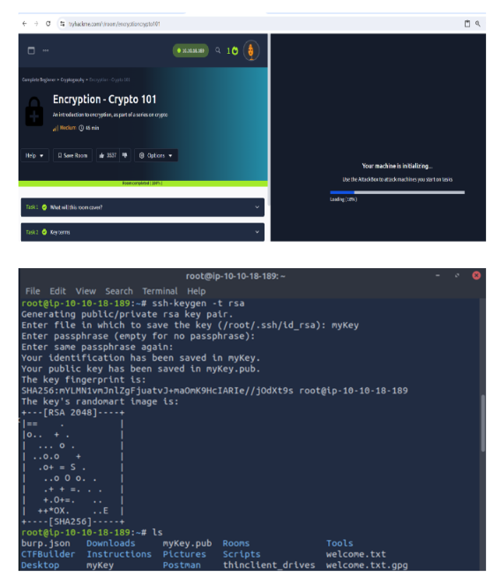

EXP.NO:2
CRACK THE HASHES
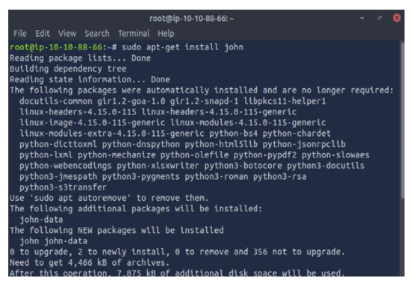
EXP.NO:3
PASSIVE AND ACTIVE RECONNAISSANCE
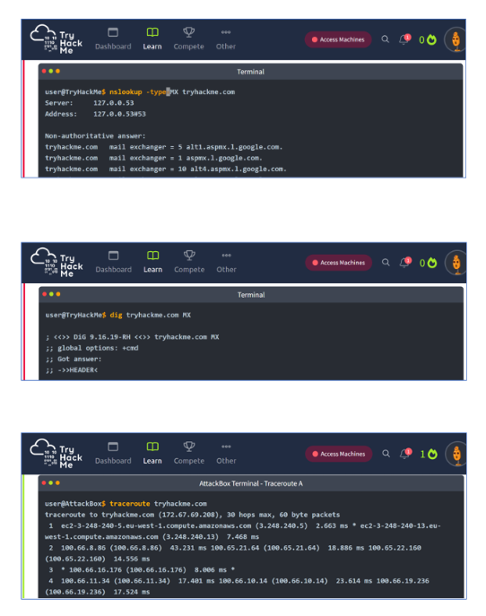

EXP.NO: 4
SQL INJECTION LAB
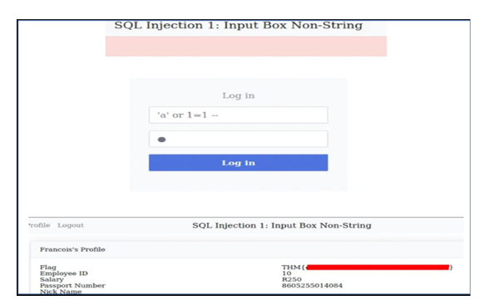
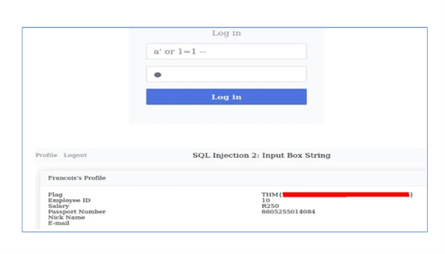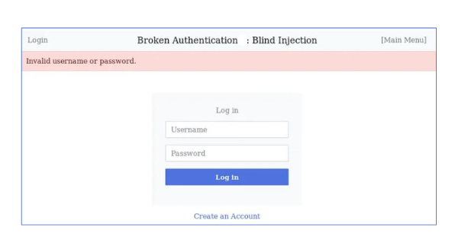
EXP.NO: 5
PROCESS CODE INJECTION

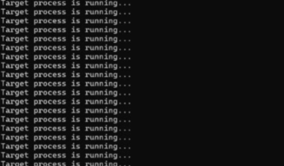
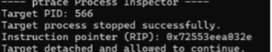

EXP.NO: 7
SNORT IDS
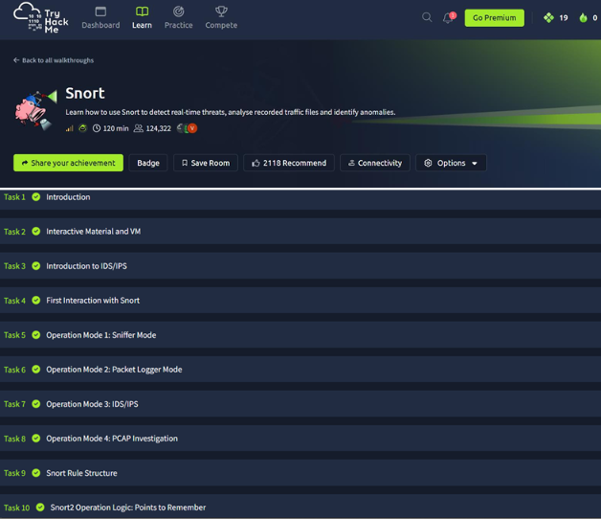

EXP.NO: 8
METASPLOIT



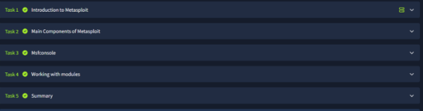

EXP.NO: 10
MITM ATTACK WITH ETTERCAP
